*Sent to all Members*  
  
October 13, 2024  
  
Dear {%FName%},

This is a Rotary Minute from District 6220 Governor Roger Utnehmer (Oot-name-er).

Please read at club meetings and post in newsletters and Rotary social media.

===========================================================

AMERICAN INDIAN NEIGHBORS PROVIDE ROTARY’S GREATEST OPPORTUNITY TO BUILD GOODWILL AND BETTER FRIENDSHIPS

“Rotary’s greatest opportunity to build goodwill and better friendships is with our American Indian neighbors.

The week the U.S. has designated Indigenous Peoples Day, let us consider seizing opportunity. Every Rotary club in our district meets on land formerly occupied by indigenous peoples.

Consider the simple gesture of starting club meetings with a Land Acknowledgement Statement like Rotary International uses to begin all sessions at international conferences. (See below)

Allocate a series of club programs to learning about American Indian history, culture, and contemporary challenges. Invite your indigenous neighbors to present, consider events at their facilities, explore joint service projects and grant applications. Sponsor Indigenous students as Rotary Youth Exchange participants….or create an exchange program between Indigenous and non-Native students.

You can’t expect two hundred years of history to be condensed in a twenty-minute club presentation but it is a start, a gesture of respect and a statement of friendship long over-due.

A sincere cultural appreciation initiative with American Indians also presents Rotary with opportunity to model civility in civic discourse. Consider the long-term value of Rotary being a safe, hostility-free place to have essential discussions of important issues. If people of good will, with differing opinions, can express them respectfully at Rotary we will be better citizens, conciliators and models of compromise and consensus.

We can start with a commitment to what Ignatius of Loyola preached and practiced, “precision of thought and economy of expression.”

If Rotary clubs brought together people committed to precision of thought and economy of expression, conversation will encourage debate, compromise, and better decision-making.

Simple gestures can convey powerful messages. Let’s start sending powerful messages to those to whom we owe much, our American Indian neighbors.

Precision of thought and economy of expression.

Thank you.”

ROGER UTNEHMER  
Rotary District 6220  
District Governor 2024-25  
(C) 920 495 9677

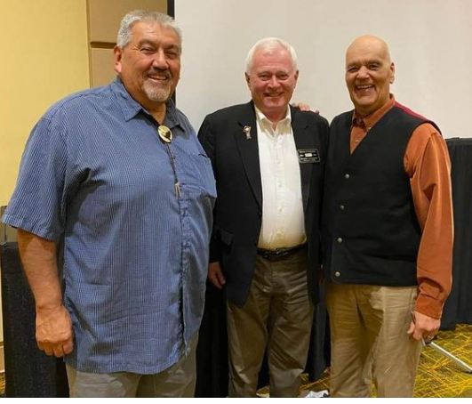

**Land Acknowledgment Statement**

“Today we are meeting on lands formerly occupied by Indigenous peoples, many of whom were forced to leave generations ago.

Rotary International recognizes the historical and ongoing impact of colonization on Indigenous communities.

We pay respect for our First Nation elders, past, present, and future.

We express our respect and gratitude to all First Nation people for preserving and protecting the lands on which Rotarians meet.”